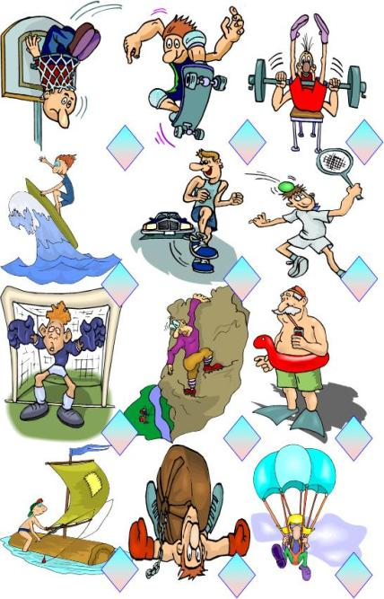
Note : Tu peux t’aider de ton manuel ou de ton cours pour réaliser ces exercices !!!
A° Numérote chaque image.
- swimming
- basketball
- skating
- surf
- running
- tennis
- football
- climbing
- sailing
10. parachute jumping
11. weight lifting

B° Maintenant écris 5 phrases à partir des images en utilisant CAN/CAN’T.
Exemple : He can play football but he can’t play basketball.

……………………………………………….……………………………………………………
……………………………………………….…………………………………………………….
……………………………………………….……………………………………………………
……………………………………………….…………………………………………………….
……………………………………………….……………………………………………………
……………………………………………….…………………………………………………….
……………………………………………….……………………………………………………
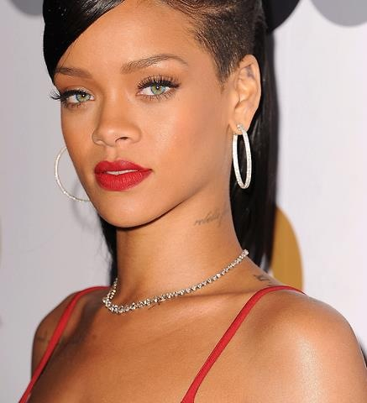
Date : ________________________________
Lis attentivement le texte pour pouvoir répondre aux questions.
Rihanna is a singer. She’s from Barbados but now she works all over the world. She’s twenty-four years old and she’s very famous. She has got big brown eyes and she’s tall.
She has got a lot of hit songs: Umbrella, Don’t stop the music, Disturbia, etc. The songs are so good that she has a lot of fans all over the world. They love her music.
Rihanna’s mother is called Monica and her father’s name is Ronald.
1. Indique si les phrases suivantes sont vraies (V) ou fausses (F).
- Rihanna isn’t a teacher. ___
- Rihanna is Australian. ___
- She has got big brown eyes. ___
- Rihanna is very short. ___
- She hasn’t got any fans. ___
- Monica and Ronald are her grandparents. ___
2. Réponds aux questions en faisant des phrases complètes.
- What’s Rihanna’s job?
____________________________________________________________________________
- Where does she come from?
____________________________________________________________________________
- How old is she?
___________________________________________________________________________
- What colour are her eyes?
____________________________________________________________________________
- What’s her mother’s name?
____________________________________________________________________________
- What’s her father’s name ?
____________________________________________________________________________

